create database amazon_data;

use amazon_data;

describe sales_analysis;

select * from sales_analysis;

-- SQL Capstone Project on Amazon Slaes Data

-- Creating a New column time_of_day

alter table sales_analysis

add column time_of_day varchar(20) after Time;

-- updating values in time_of_day column

set sql_safe_updates = 0;

update sales_analysis

set time_of_day =

case

when time(time) >= '00:00:00' and time(time) < '12:00:00' then 'Morning'

when time(time) >= '12:00:00' and time(time) < '18:00:00' then 'Afternoon'

else 'Evening'

end;

select * from sales_analysis;

-- Creating a New column day_name

alter table sales_analysis

add column day_name varchar(20) after Date;

update sales_analysis

set day_name=

case dayofweek(date)

when 1 then 'Sun'

when 2 then 'Mon'

when 3 then 'Tue'

when 4 then 'Wed'

when 5 then 'Thu'

when 6 then 'Fri'

when 7 then 'Sat'

end;

select * from sales_analysis;

-- Adding a New column month_name

alter table sales_analysis

add column month_name varchar(20) after day_name;

-- updating values in month_name column

update sales_analysis

set month_name =

case month(date)

when 1 then 'Jan'

when 2 then 'Feb'

when 3 then 'Mar'

when 4 then 'Apr'

when 5 then 'May'

when 6 then 'Jun'

when 7 then 'Jul'

when 8 then 'Aug'

when 9 then 'Sep'

when 10 then 'Oct'

when 11 then 'Nov'

when 12 then 'Dec'

end;

select * from sales_analysis;

-- Business Que

-- 1.What is the count of distinct cities in the dataset?

select distinct city from sales_analysis;

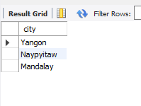

-- 2.For each branch, what is the corresponding city?

select distinct branch,city from sales_analysis;

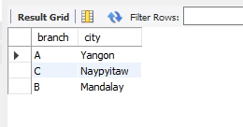

-- 3.What is the count of distinct product lines in the dataset?

SELECT COUNT(DISTINCT `Product line`) FROM sales_analysis;

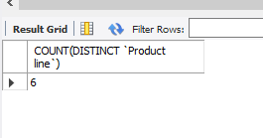

SELECT DISTINCT `Product line` FROM sales_analysis;

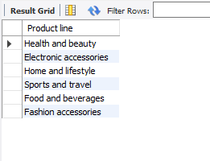

-- 4.Which payment method occurs most frequently?

select payment, count(*) as frequency

from sales_analysis

group by payment

order by frequency desc;

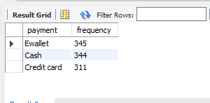

-- 5.Which product line has the highest sales?

select `Product line`, count(*) as total_sales

from sales_analysis

group by `Product line`

order by total_sales desc;

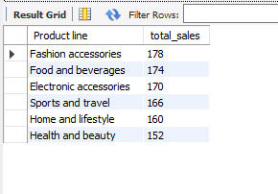

-- 6.How much revenue is generated each month?

select month_name, round(sum(total),2) as revenue

from sales_analysis

group by month_name

order by revenue desc;

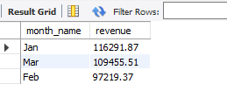

-- 7.In which month did the cost of goods sold reach its peak?

select month_name, round(sum(cogs),2) as total_cogs

from sales_analysis

group by month_name

order by total_cogs desc;

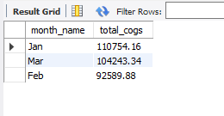

-- 8.Which product line generated the highest revenue?

select `Product line`, round(sum(total),2) as highest_revenue

from sales_analysis

group by `Product line`

order by highest_revenue desc;

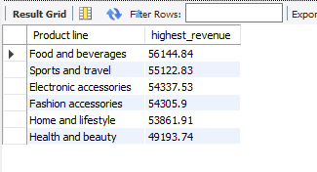

-- 9.In which city was the highest revenue recorded?

select city, round(sum(total),2) as highest_revenue

from sales_analysis

group by city

order by highest_revenue desc;

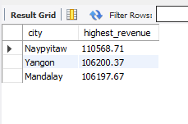

-- 10.Which product line incurred the highest Value Added Tax?

select `Product line`, round(sum(`Tax 5%`), 2) as Total_vat

from sales_analysis

group by `Product line`

order by `Total_vat` desc;

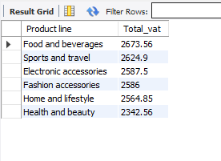

-- 11.For each product line, add a column indicating "Good" if its sales are above average, otherwise "Bad."

select `product line`, round(sum(total),2) as Total_sales,

case

when sum(total) > (

select avg(total_sales)

from(

select `product line`, sum(total) as Total_sales

from sales_analysis

group by `product line`

) as subquery

) then 'Good'

else 'Bad'

end as sales_status

from sales_analysis

group by `product line`

order by total_sales desc;

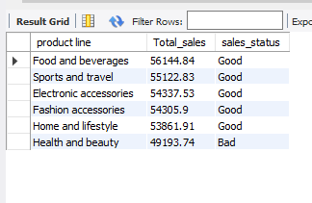

-- 12.Identify the branch that exceeded the average number of products sold.

select branch, sum(quantity) as total_quantity

from sales_analysis

group by branch

having sum(quantity) > (select avg(quantity) from sales_analysis);

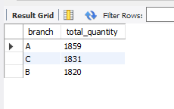

-- 13.Which product line is most frequently associated with each gender?

select `product line`, gender, count(*) as frequency

from sales_analysis

group by gender, `product line`

order by frequency desc;

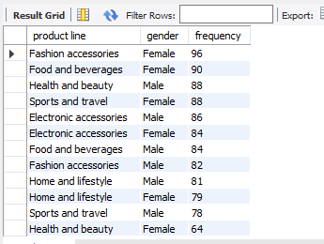

-- 14.Calculate the average rating for each product line.

select `product line`, round(avg(rating),3) as avg_rating

from sales_analysis

group by `product line`

order by avg_rating desc;

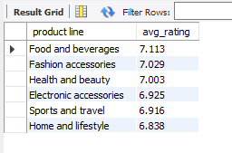

-- 15.Count the sales occurrences for each time of day on every weekday.

select time_of_day, day_name, count(*) as sales_occurence

from sales_analysis

where day_name in ('Mon','Tue','Wed','Thu','Fri')

group by time_of_day, day_name

order by sales_occurence desc;

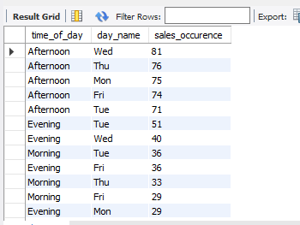

-- 16.Identify the customer type contributing the highest revenue.

select `customer type`, round(sum(total), 2) as highest_revenue

from sales_analysis

group by `customer type`

order by highest_revenue desc;

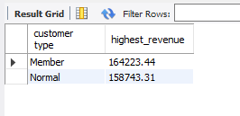

-- 17.Determine the city with the highest VAT percentage.

select city,

round(sum(`Tax 5%`), 2) as higest_vat,

round(sum(Total), 2) as total_sales,

round((sum(`Tax 5%`) / sum(Total)) * 100,2) as vat_percentage

from sales_analysis

group by city

order by higest_vat desc;

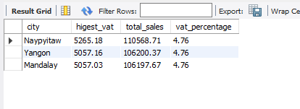

-- 18.Identify the customer type with the highest VAT payments.

select `Customer type`, round(sum(`Tax 5%`),2) as highest_vat_payments

from sales_analysis

group by `Customer type`

order by highest_vat_payments desc;

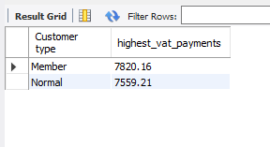

-- 19.What is the count of distinct customer types in the dataset?

select count(distinct `Customer type`) as distinct_customer_type

from sales_analysis;

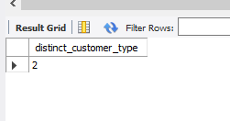

-- 20.What is the count of distinct payment methods in the dataset?

select count(distinct payment) as distinct_paymnet_method

from sales_analysis;

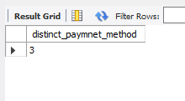

-- 21.Which customer type occurs most frequently?

select `Customer type`, count(`Customer type`) as frequency

from sales_analysis

group by `Customer type`

order by frequency desc;

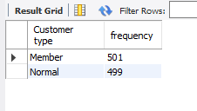

-- 22.Identify the customer type with the highest purchase frequency.

select `Customer type`, count(*) as highest_purchase

from sales_analysis

group by `Customer type`

order by highest_purchase desc;

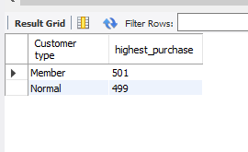

-- 23.Determine the predominant gender among customers.

select gender, count(*) as predominant_gender

from sales_analysis

group by gender

order by predominant_gender desc;

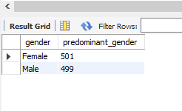

-- 24.Examine the distribution of genders within each branch.

select branch,gender, count(*) as gender_count

from sales_analysis

group by gender,branch

order by gender_count desc;

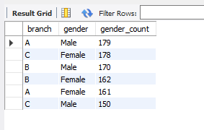

-- 25.Identify the time of day when customers provide the most ratings.

select time_of_day, count(rating) as rating_count

from sales_analysis

group by time_of_day

order by rating_count desc;

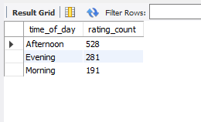

-- 26.Determine the time of day with the highest customer ratings for each branch.

select branch,time_of_day, round(avg(rating),2) as average_rating

from sales_analysis

group by branch,time_of_day

order by average_rating desc;

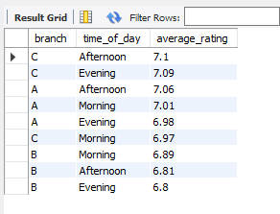

-- 27.Identify the day of the week with the highest average ratings.

select day_name, round(avg(rating),2) as highest_rating

from sales_analysis

group by day_name

order by highest_rating desc;

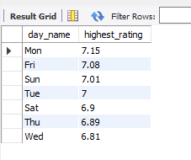

-- 28.Determine the day of the week with the highest average ratings for each branch.

select branch,day_name, round(avg(rating),2) as highest_average_rating

from sales_analysis

group by branch,day_name

order by highest_average_rating desc;

